Java Problemsheet - 6

Name: Kaaviya S S Roll. no: 22PT15

1. Write a program for example of try and catch block. In this check whether the given array size is negative or not.

import java.util.Scanner;

public class NegativeSizeArray
{
public static void main(String[] args)
{
Scanner obj = new Scanner(System.in);
System.out.print("Enter size of array: ");
int n = obj.nextInt();
try {
int[] arr = new int[n];
System.out.println("Array length: " + arr.length);
System.out.println("Execution successful!");

} catch (Exception e) {
System.out.println(e);
System.out.println("Negative size array is not valid!");
}

obj.close();
}
}

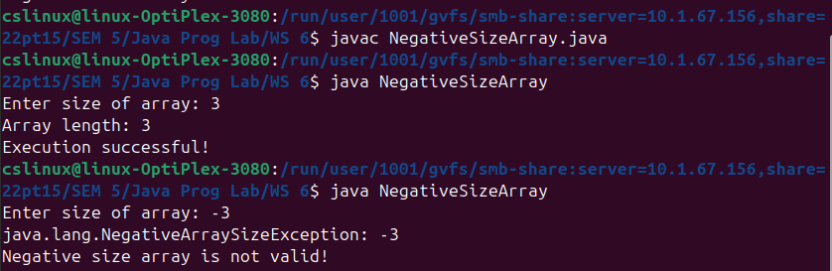

—----------------------------------------------------------------------------------------------------------------------------

2. Write a program for example of multiple catch statements occurring in a program.

import java.util.Scanner;

public class MultipleCatch
{
public static void main(String[] args) {

Scanner obj = new Scanner(System.in);
System.out.print("Enter divisor x for division 30/{x}: ");
int x = obj.nextInt();
System.out.print("Given arr[5], enter an index to store the above result: ");
int n = obj.nextInt();

try {
int arr[] = new int[5];
arr[n] = 30/x;
System.out.println(arr[n]);

} catch (ArithmeticException ae) {
System.out.println("Division by zero exception!");
} catch (Exception e) {
System.out.println("Array Out of bounds exception!");
}

obj.close();
}
}

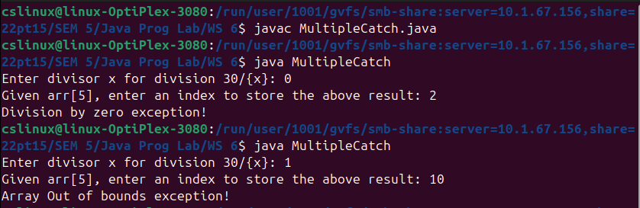

—----------------------------------------------------------------------------------------------------------------------------

3. Write a program to illustrate sub class exception precedence over base class.

//Subclass precedence over base class

public class ExceptionPrecedence
{
public static void main(String[] args)
{
try {
int result = 10 / 0; // This will throw ArithmeticException
}
catch (ArithmeticException e) {
// This block catches the specific subclass exception
System.out.println("Subclass exception...");
System.out.println(e);
}
catch (Exception e) {
// This block catches the more general base class exception
System.out.println("Base class exception...");
System.out.println(e);
}

System.out.println("Program continues...");
}
}

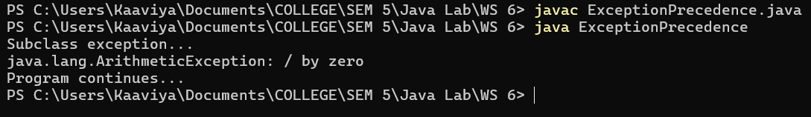

—----------------------------------------------------------------------------------------------------------------------------

4. Write a program to do division of two numbers. Make function called doDivision( ) to do division of two numbers. During the division process if runtime error may occur throw error to calling function. Handle ArithmeticException, ArrayIndexOutofBoundsException, NumberFormatException in main( ) method only.

public class Division
{
public static void main(String[] args)
{
//normal division
try {
doDivision(10, 5);
} catch (Exception e) {
System.out.println(e);
}

//arithmetic exception
try {
doDivision(10,0);
} catch (Exception ae) {
System.out.println(ae);
}

//Number format exception
try {
doDivision("ten",5);
} catch (Exception ne) {
System.out.println(ne);
}

//array index out of bound exception
try {
int arr[]={1};
doDivision(arr[1], 5);
} catch (Exception aie) {
System.out.println(aie);
}
}

public static void doDivision(Object num1, Object num2)
{
if(num1 instanceof Integer && num2 instanceof Integer)
{
int n1 = (int) num1;
int n2 = (int) num2;

if(n2==0) {
throw new ArithmeticException(n1 + "/" + n2 + " -> Division by Zero error!");
}

System.out.println("Result: " + n1 + "/" + n2 + "=" + n1/n2);
}
else {
throw new NumberFormatException(num1 + "/" + num2 + " -> Number Format error!");
}
}
}
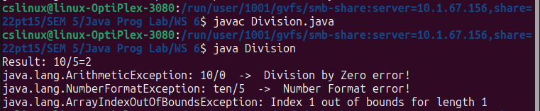

—---------------------------------------------------------------------------------------------------------------------------

5. Write a program in Java to display name and roll number of students. Initialize respective array variables for 10 students. Handle ArrayIndexOutOfBoundsExeption, so that any such problem doesn’t cause illegal termination of program.

import java.util.Scanner;

public class StudentsRoll
{
String name;
int roll;

StudentsRoll(String name, int roll)
{
this.name = name;
this.roll = roll;
}

public void display()
{
System.out.println("Roll:" + this.roll + " Name:" + this.name);
}

public static void main(String[] args)
{
Scanner obj = new Scanner(System.in);

StudentsRoll[] students = new StudentsRoll[10];
System.out.println("Enter the roll number and name of 10 students: ");
for(int i=0; i<10; i++)
{
int roll = obj.nextInt();
String name = obj.next();
students[i] = new StudentsRoll(name, roll);
}

//invoking ArrayIndexOutOfBoundException
System.out.println("Enter the roll number and name of 10 students: ");
try {
for(int i=0; i<=10; i++) {
students[i].display();
}
} catch (ArrayIndexOutOfBoundsException ae) {
System.out.println("Error: " + ae);
System.out.println("Trying to access 11th object!");
}
obj.close();
}
}

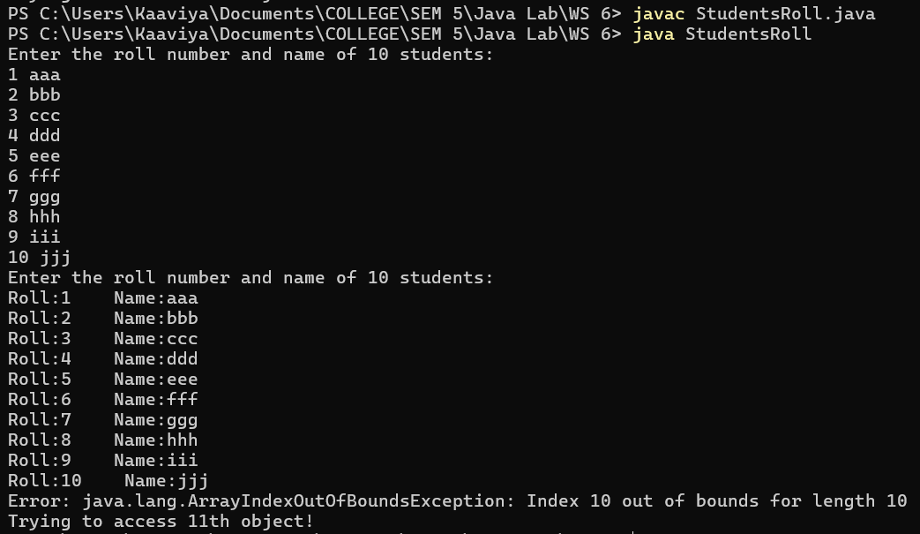

—---------------------------------------------------------------------------------------------------------------------------

6. Create a user-defined exception class called “NoMatchException” using extends keyword. Write a constructor for this class that takes a string argument and stores it inside the object with a string handle. Write a method that prints out the stored string. Create a try-catch clause to exercise the created exception when a user entered string is not equal to “India”;

import java.util.Scanner;

public class NoMatchException extends Exception
{
String message;

public NoMatchException(String message)
{
this.message = message;
}

public void display()
{
System.out.println("NoMatchException: " + message);
}

public static void main(String[] args)
{
Scanner obj = new Scanner(System.in);

System.out.print("Enter a country: ");
String country = obj.nextLine();

try {
if(!country.equals("India"))
throw new NoMatchException("Country does not match!");
else
System.out.print("Country is matched!");
}
catch(NoMatchException e) {
e.display();
}

obj.close();
}
}

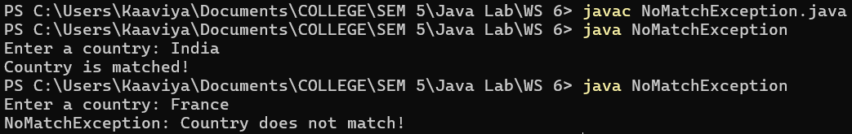

—----------------------------------------------------------------------------------------------------------------------------

7. Write an application that displays a series of at least five student ID numbers (that you have stored in an array) and asks the user to enter a numeric test score for the student. Create a ScoreException class, and throw a ScoreException for the class if the user does not enter a valid score (less than or equal to 100). Catch the ScoreException, display an appropriate message, and then store a 0 for the student’s score. At the end of the application, display all the student IDs and scores.

import java.util.Scanner;

public class ScoreException extends Exception
{
String message;

public ScoreException (String message) {
this.message = message;
}

public void display() {
System.out.println("ScoreException: " + message);
}

public static void main(String[] args)
{
Scanner obj = new Scanner(System.in);
int[] studentID = {1, 2, 3, 4, 5};
int[] marks = new int[5];

for(int i=0; i<5; i++)
{
System.out.print("Enter the score for student " + studentID[i] + ": ");
try {
int score = obj.nextInt();
if(score<0 || score>100) {
throw new ScoreException("Invalid score!");
}
marks[i] = score;
}
catch(ScoreException e) {
e.display();
marks[i] = 0;
}
}

System.out.println("\nDisplaying the scores of all the students: ");
for(int i=0; i<5; i++)
{
System.out.println("StudentID: " + studentID[i] + "\t mark: " + marks[i]);
}

obj.close();
}
}

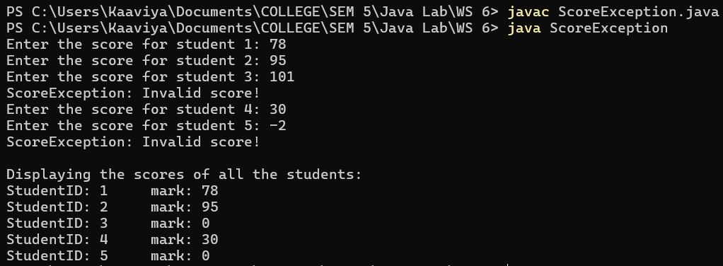

—----------------------------------------------------------------------------------------------------------------------------

8. A typical requirement of a custom exception called “WeakPasswordException” would be for validation purposes. In this exercise, Let's validate a password input. A password is said to be strong if it satisfies the following criteria
i) It should be a minimum of 10 characters and a maximum of 20 characters.
ii) It should contain at least one digit.
iii) It should contain at least one special character (non-numeric, non-alphabetic).
iv) It should contain at least one letter.
If the password fails any one of the criteria, it is considered as weak.

import java.util.Scanner;

class WeakPasswordException extends Exception
{
String message;

public WeakPasswordException (String message) {
this.message = message;
}

public void display() {
System.out.println("WeakPasswordException: " + message);
}
}

public class PasswordValidator
{
public static void ValidatePassword(String password) throws WeakPasswordException
{
if(password.length()<10 || password.length()>20) {
throw new WeakPasswordException("Password length should be 10-20 characters!");
}

boolean hasDigit = false;
boolean hasSpecialChar = false;
boolean hasLetter = false;

for(char ch : password.toCharArray())
{
if(Character.isDigit(ch))
hasDigit = true;
else if(!Character.isLetter(ch) && !Character.isDigit(ch))
hasSpecialChar = true;
else if(Character.isLetter(ch))
hasLetter = true;
}

if(!hasDigit)
throw new WeakPasswordException("Password Should have atleast a 'Digit'.");
if(!hasSpecialChar)
throw new WeakPasswordException("Password Should have atleast a 'Special Character'.");
if(!hasLetter)
throw new WeakPasswordException("Password Should have atleast a 'Letter'.");
}

public static void main(String[] args)
{
Scanner obj = new Scanner(System.in);

System.out.print("Enter the password: ");
String password = obj.nextLine();

try {
ValidatePassword(password);
System.out.println("Password is Strong!");
}
catch (WeakPasswordException w) {
w.display();
}

obj.close();
}
}





